EXP 13

AIM: Design PDA using simulator to accept the input string aabb

INPUT:

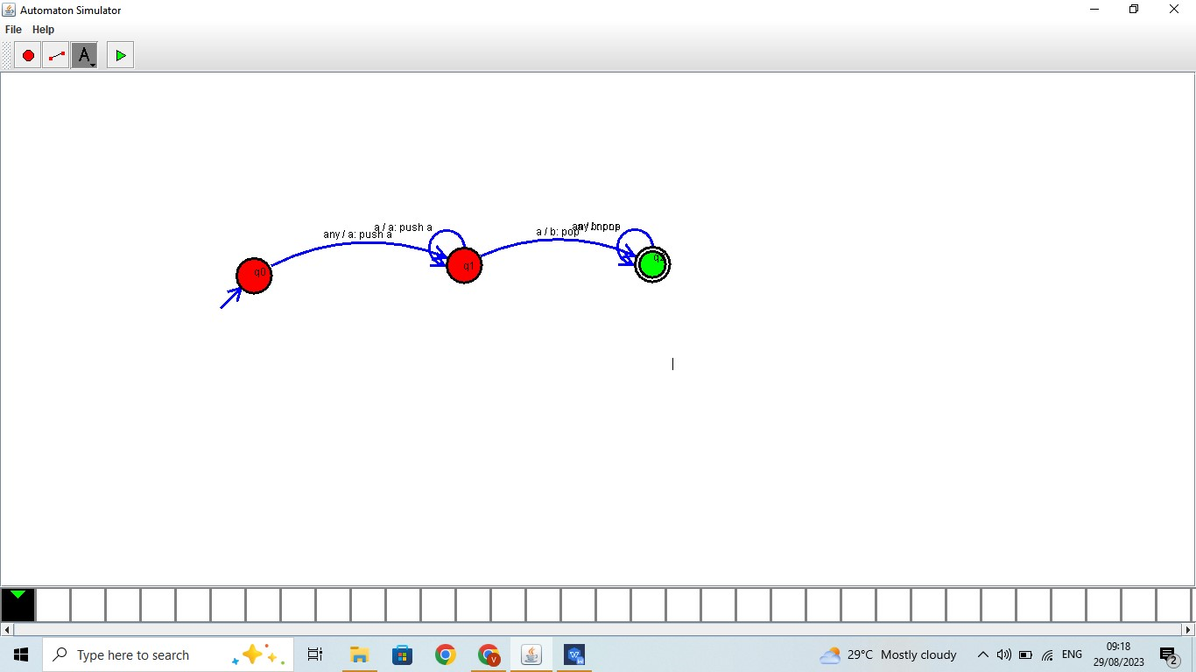

OUTPUT:



RESULT: Design PDA using simulator to accept the input string aabb is successfully verified